**AZURE DATABASE for PostgreSQL for ACME Corp.**

**Submitted By: Ezhilan Yugesh, Sharma Vinayak, Soni Yash**

**COMPANY PROFILE**

A leading e-commerce company, ACME Corp, has been using a PostgreSQL database hosted on-premises for managing its customer, inventory, and transaction data. With a fast-growing customer base and increased online traffic, ACME Corp is struggling with the rising costs of maintaining hardware and ensuring high availability and scalability of its database.

The company's IT department has been facing challenges managing the increasing demands of their PostgreSQL database, especially considering their need for higher availability, scalability, and security. Additionally, they have had to deal with the time-consuming task of database administration, which has diverted resources from their core product development.

As ACME Corp scales, the need for a more robust, scalable, and efficient database solution has become evident. ACME is facing the following challenges with their current on-premises PostgreSQL setup:

* **Scalability**: The growing volume of data and traffic is leading to performance issues, making it difficult to meet the rising demand.
* **Availability**: The on-premises setup can't guarantee the desired level of availability. Downtimes, maintenance, or network issues disrupt the customer experience.
* **Maintenance**: The cost and complexity of hardware maintenance and database administration are significantly high.
* **Backup and Disaster Recovery**: ACME is struggling to implement a comprehensive backup and disaster recovery strategy cost effectively.
* **Security**: With an increase in cyber threats, ensuring top-notch security is a significant challenge to maintain credibility and trust in the market.

**PRODUCT OVERVIEW**

Azure Database for PostgreSQL is a managed service provided by Microsoft Azure that enables the deployment and scaling of PostgreSQL databases in the cloud. The service handles most of the database management functions such as upgrading, patching, backups, and monitoring without user intervention, which allows developers to focus more on the development and less on administration. It supports open-source community editions of PostgreSQL, thus maintaining compatibility with tools and applications that were designed for PostgreSQL (Microsoft, n.d.).

**SYSTEM CAPABILITIES, PERFORMANCE, AND SCALABILITY**

Azure Database for PostgreSQL Azure offers a fully managed PostgreSQL database service that provides scalability, high availability, and security that ACME needs. Here's how Azure Database for PostgreSQL addresses ACME's concerns:

* **Scalability**: Azure provides a scalable solution to accommodate increasing data volumes and customer traffic. ACME can dynamically scale up or down as per business needs with Azure's flexible compute and storage options (Microsoft, 2022).

One of the key capabilities of Azure Database for PostgreSQL is its ability to scale compute resources on-demand. Azure’s Flexible Server deployment option allows developers to scale the compute resources up or down, depending on the workload needs, providing cost optimization and performance benefits (Microsoft, 2022).

* **Availability**: Azure ensures high availability with its built-in fault tolerance, automatic updates, and maintenance, ensuring minimal downtime and improved customer experience by utilizing artificial intelligence (Microsoft, 2023).

Azure Database for PostgreSQL also comes with built-in high availability and fault tolerance, which minimizes the chance of data loss and prevents downtime (Microsoft, 2023).

* **Maintenance**: As a fully managed service, Azure handles most of the administrative tasks such as hardware maintenance, database setup, updates, and patching, freeing up ACME's IT resources to focus on other strategic areas (Kaufmann & Duey, 2022)
* **Backup and Disaster Recovery**: Azure's automatic backup and Point-In-Time Recovery (PITR) feature, along with geo-redundant storage options, make disaster recovery easier and more efficient for ACME (Kaufmann & Duey, 2022).
* **Security**: Azure provides built-in security controls and advanced threat protection to safeguard ACME's data. It also offers encryption for data at rest and in transit, reducing the risk of data breaches. Security is a primary focus in Azure Database for PostgreSQL. It supports features like Azure Active Directory (Azure AD) authentication, which provides a central place for managing database access. It also offers features like firewall rules, virtual network service endpoints, managed private endpoints, SSL enforcement, and Threat Detection to keep the data secure. Moreover, Azure’s Advanced Threat Protection provides an extra layer of security by detecting potential malicious activities and providing security alerts (Microsoft, 2023).
* **Monitoring and Diagnostic Tools:** Microsoft also provides comprehensive monitoring and diagnostics tools for Azure Database for PostgreSQL. It integrates with Azure Monitor and Azure Log Analytics, providing a unified way to monitor the performance of your applications, infrastructure, and network. These tools allow users to track queries and determine how resources are being used, providing insights that can be used to optimize performance (Microsoft, 2023).

Azure Database for PostgreSQL has been utilized by many companies across different industries for the scalability of their products. Here are a couple of examples used by established companies in the industry:

**1. Scandinavian Airlines (SAS):** Scandinavian Airlines (SAS) is a digital leader in the aviation industry. The company has a history of customer-friendly innovations, including SAS App a popular booking apps used by millions of travelers each year (Microsoft, 2021).

SAS faced challenges in terms of infrastructure costs and required more agility for its development teams. The airline turned to Azure Database for PostgreSQL to address these challenges. This platform allows for seamless and secure data migration, and it reduces the complexity of app development. By using Azure Database for PostgreSQL, SAS has been able to speed up its app development processes, lower its costs, and provide its developers with more flexibility. SAS turned to Azure Database for PostgreSQL - Flexible Server. This solution not only provided the needed high availability and resilience but also accelerated application development. The booking app now runs in Azure Kubernetes Service (AKS), backed by Azure Database for PostgreSQL - Flexible Server. This allows the app team to focus on innovation rather than managing infrastructure (Microsoft, 2021).

**2. Kantar Group:** The Kantar Group, a premier data, insights, and consulting firm based in London, sought a replacement for its existing system that could efficiently cater to data analytics needs and client report requests simultaneously. Their pre-existing solution, an on-premises Extract-Transform-Load (ETL) pipeline, was used for high-throughput transactional applications alongside various engines for analytics and reporting applications. However, Kantar found the solution they needed in Azure Database for PostgreSQL, as it was the only platform capable of managing a full day of their reporting requirements.

Being built on open-source PostgreSQL, Azure Database not only eased Kantar's transition to Azure, but also aligned with their objective of code reuse. This shift transformed their IT budget from a capital expenditure to a more predictable, operational pay-as-you-go expense. With Azure Database for PostgreSQL, Kantar has been able to expedite insights derived from their data and more efficiently deliver client report requests. The compatibility of Azure Database with PostgreSQL minimized the need for extensive refactoring and data model changes, proving advantageous for the company.

**CAPACITY TO INTEGRATE WITH OTHER PROMINENT SOFTWARE SYSTEMS/SOLUTIONS**

Azure Database for PostgreSQL offers an array of opportunities for integration with diverse software applications and platforms. Let's discuss a few instances where different firms have successfully coupled their software with Azure Database for PostgreSQL:

**1. InfluxData:** InfluxData, with its time series database InfluxDB, collaborated with Azure Database for PostgreSQL. In this setting, PostgreSQL is used as a metadata repository to boost the storage and data administration capabilities of InfluxDB. This marriage enables InfluxDB to store and extract data from PostgreSQL at a larger scale while also carrying out analytics with the built-in functions of PostgreSQL (InfluxData, n.d.).

**2. DBeaver:** DBeaver, an all-in-one database management tool, has integration with Azure Database for PostgreSQL. Through this alliance, users can comfortably manage and interact with their PostgreSQL databases on Azure. Thanks to its user-friendly interface and comprehensive set of features, DBeaver becomes a potent tool for database administration, query development, and data export (Verma, 2022).

**3. Tableau:** Tableau, a platform for business intelligence and data visualization, synchronizes with Azure Database for PostgreSQL. With this integration, Tableau users can directly connect to their PostgreSQL databases on Azure to create dynamic and real-time dashboards and reports. The potent visualization capabilities of Tableau, combined with PostgreSQL's robustness, can assist organizations in extracting valuable data insights (Corneli, 2021).

**4. Django:** Azure Database for PostgreSQL is compatible with Django, a sophisticated Python web framework. This compatibility allows developers to craft secure and scalable web applications using Django, with PostgreSQL serving as the backend. Microsoft delivers a fully managed environment, enabling developers to concentrate more on coding and less on database management (Dadakh, 2023).

**IMPLEMENTATION TIME AND COSTS**

1. **Implementation Time Of Azure Database For PostgreSQL For The Project**

The implementation time for Azure PostgreSQL in an organization can vary based on several factors. Some of the key considerations that can impact the implementation timeline are:

1. **Project Scope:** The size and complexity of the project can significantly affect the implementation time. Setting up a straightforward deployment with minimal configurations may be faster than implementing a more extensive and intricate deployment, which involves tasks such as data migration, application integration, and addressing security concerns.
2. **Database Deployment:** Whether deploying a new instance or migrating from an existing system, the process for setting up Azure PostgreSQL should adhere to the following steps:

* **Planning:** Organizations need to strategize the database setup by doing an initial analysis to determine its required size and scalability, choosing the appropriate pricing tier, and deciding on the deployment type (single server or Hyperscale).
* **Deployment:** Once the database planning is done, users can create and deploy the Azure PostgreSQL server on Azure using the interface or CLI.
* **Configuration:** After database deployment, users can configure firewalls, authentication, backup, and other configurations based on the organization's needs. Organizations may need to meet specific security and compliance requirements, and configuring security measures and ensuring compliance can add to the implementation timeline.
* **Data Migration:** If the organization already has an existing database system that needs to be migrated to Azure PostgreSQL, the time required for data migration can be a major factor. Larger data volumes may take more time to transfer and validate (Microsoft,2023).

1. **Application Integration:** If the database needs to be integrated with existing applications or services, additional time may be required to ensure seamless integration and testing. When implementing Azure PostgreSQL, it's essential to ensure seamless communication and interaction between the database and the applications that rely on it. It's crucial to assess the applications that will interact with the database, understanding the data requirements, query patterns, and specific functionalities that applications need from the database.
2. **Testing and Quality Assurance:** Proper testing and quality assurance play a vital role in guaranteeing that the new database solution functions as intended and meets the desired objectives. Thorough testing is necessary to identify and address any potential issues or defects before the database is deployed in a production environment. The extent of testing required can significantly influence the overall implementation time.
3. **Onboarding and Orientation:** If the organization's staff requires training on how to effectively utilize Azure PostgreSQL or gain a comprehensive understanding of the new system, this additional requirement can extend the overall implementation timeline. Training becomes an essential aspect of the implementation process to ensure that the organization's employees, including database administrators, developers, and other relevant personnel, are well-equipped to work with the new technology proficiently.

1. **Costs Associated with Implementation Of Azure Database For PostgreSQL**

The cost of implementing Azure PostgreSQL within an organization can vary based on several factors. Some crucial elements that can impact the implementation cost are as follows:

1. **Database Capacity:** The cost of using Azure PostgreSQL is directly influenced by the size of the database and the desired performance level, which can be measured in terms of Virtual Cores (vCores). Azure PostgreSQL provides different service tiers that cater to different workload requirements:

* The **Burstable Service** in Azure PostgreSQL is tailored for workloads with dynamic compute demands, offering a range of instance sizes from B1ms to B20ms, with 1 to 20 cores and storage capacity ranging from 2GiB to 80 GiB. The monthly cost for these instances falls within the range of $17.914 to $1433.097 (Fig. 3) (Microsoft, n.d.).
* The **General-Purpose service** tier in Azure PostgreSQL caters to most business workloads that need a balanced combination of compute and memory along with scalable input/output throughput. For the General-Purpose AMD instances, Azure offers a variety of instance sizes, ranging from D2ads v5 to D96ads v5, with 2 to 96 cores and storage capacity ranging from 8GiB to 384GiB. The monthly cost for these instances varies within the range of $191.726 to $9202.804 (Fig. 4) (Microsoft, n.d.).
* The **Memory Optimized service** tier in Azure PostgreSQL is designed for high-performance database workloads that demand in-memory performance to achieve faster transaction processing and higher concurrency. For general-purpose AMD instances, Azure provides a selection of instance sizes, ranging from E2ads v5 to E96ads v5, offering 2 to 112 cores and storage capacity ranging from 16GiB to 896GiB. The monthly cost for these instances falls within the range of $266.285 to $13846.812 (Fig. 5) (Microsoft, n.d.).

1. **Data Storage Demands:** Organizations must carefully estimate their storage needs based on the data they intend to store and access. The amount of data to be stored will impact on the storage costs associated with the chosen Azure PostgreSQL plan. For flexible servers the Storage cost per month is $0.168 per GiB of data (Microsoft, n.d.).
2. **Data Protection and Failover Measures**: Azure PostgreSQL offers a range of data protection and high availability features through its backup and redundancy options. While these features provide invaluable benefits, they may come at an additional cost. Implementing such measures to fortify the database against potential risks may increase the overall implementation cost. The basic back-up storage cost is $0.140 GiB per month (Microsoft, n.d.).
3. **Professional Services and Support:** Professional services and support are essential during the implementation process, and organizations may choose to engage Azure specialists or consultants to assist them. However, the cost of these services can vary significantly based on the level of service required. For instance, developer support may cost around USD $29 per month, the standard plan could cost approximately $100 per month, while the professional-level support may be priced at USD $1000 per month (Microsoft, n.d.).
4. **Training:** Training and skill development expenses should be considered if the organization's IT team needs training to effectively handle and maintain Azure PostgreSQL.

According to ESG's analysis, migrating on-premises PostgreSQL instances to Azure Database for PostgreSQL can result in significant cost savings. ESG's 3-year modeled scenario found that Azure Database for PostgreSQL provided up to a 62% lower total cost over a three-year period compared to continuing to operate on-premises infrastructure. This included an 84% reduction in the operational cost to deploy, manage, and maintain PostgreSQL instances on on-premises infrastructure (fig. 1) (Kaufmann & Duey, 2022).

Azure Database for PostgreSQL offloads most of the work currently performed by developers, reducing the expected cost to administer, tune, secure, protect, and maintain the databases by up to 71% (fig. 2). This leads to productivity gains and an overall increase in development capacity, potentially resulting in additional revenue for the organization (Kaufmann & Duey, 2022).

**ONGOING OPERATION AND SUPPORT NEEDS**

1. **Ongoing Operations Using Azure Database for PostgreSQL Similar to the Project at Hand**

As organizations adopt Microsoft Azure PostgreSQL for their data management needs, they must consider the ongoing operations and support requirements to ensure the continuous and efficient functioning of their database infrastructure. Azure PostgreSQL, being a cloud-based platform, demands careful attention to maintenance, monitoring, and support to maximize its benefits and ensure smooth operations.

**Database Maintenance and Optimization:**

Continuous maintenance is crucial to keeping Azure PostgreSQL in optimal condition. Regular database backups and automated maintenance tasks should be configured to ensure data integrity and quick recovery in case of unexpected events. Azure provides automated backups, and organizations must set the retention period based on their recovery point objectives (RPOs) and recovery time objectives (RTOs) (Microsoft,2023).

**Monitoring and Performance Management:**

Efficient monitoring is essential for identifying potential issues proactively and ensuring the database performs at its best. Azure offers various monitoring tools and features, such as Azure Monitor and Query Performance Insight, which provide valuable insights into the database's health and performance (Matherson, 2023). By monitoring metrics like computer utilization, storage consumption, and query execution times, organizations can detect performance bottlenecks and take necessary actions to optimize their databases (Manage Engine, n.d.).

**Security and Compliance:**

Security is a top concern for any database, and Azure PostgreSQL provides robust security features to protect sensitive data. Organizations must implement proper access controls, data encryption, and firewall rules to safeguard their data from unauthorized access. Additionally, compliance requirements, such as PCI DSS, GDPR, or HIPAA, need to be adhered to, and Azure PostgreSQL can assist in meeting these regulations (Learn-Azure, 2023).

By addressing these maintenance, monitoring, and security aspects, organizations can effectively manage and support their Azure PostgreSQL databases, ensuring they operate smoothly and securely in the cloud environment.

1. **Support required for the Azure Database for PostgreSQL internal and external, intermediate companies.**

In the event of technical issues or unexpected outages, having access to reliable and responsive support is crucial. Azure offers different support plans that organizations can choose from based on their needs. These support plans ensure that experts are available round the clock to assist with critical incidents and help troubleshoot any problems that may arise. Azure PostgreSQL provides 4 support levels: Basic, Developer, Standard, and Professional Direct (Fig: 6) (Azure, n.d.).

1. **Basic:** This support level is available at no additional cost and is included for all Azure customers with an Azure subscription. It enables 24/7 access to Azure documentation and help forums and provides email support during business hours (Azure, n.d.).
2. **Developer:** This support level is intended for trial and non-production environments. The price for developer support is USD $29 per month. It includes all the Basic support services as well as unlimited 24/7 technical support through email (Azure, n.d.).
3. **Standard:** This level of support is designed for production workload environments and includes a guaranteed response time for critical issues, as well as phone and chat support during business hours. The price for standard support is USD $100 per month (Azure, n.d.).
4. **Professional Direct:** This is the most advanced level of support and offers the most extensive range of services. It comes with guidance from a pool of ProDirect delivery managers, proactive monitoring, and optimization, as well as a guaranteed response time for all support requests, including serious issues. The price for professional support is USD $1000 per month (Azure, n.d.).

**EASE OF USE**

**User-Friendly Platform**

Azure Cloud provides step by step migration which will save time and money for ACME Corp. The platform is more compatible and familiar for our employees since it uses Microsoft technology. This, in turn, makes the transition intuitive and provides a small learning curve for those transitioning to the cloud. The customizability feature allows ACME Corp to create a system that works for the company and its business without the clutter of unused applications. Microsoft has spent considerable energy focused towards creating user friendly sysadmin tools and it includes tutorials and customer support information. The main Azure website provides whitepapers, how-to-videos, and blogs to assist users. The ease of setup, an intuitive platform, and multiple resources all add to Microsoft Cloud’s reputation for being incredibly user friendly (Jason Meilleur,2019).

**Supports Hybridization**

**Hybrid models** increase the ease of use at an organizational level. A hybrid cloud is a combination of using a public cloud and a private cloud. This will enable ACME Corp to prefer to keep a part of their data on a server at their location. ACME Corp can have authority over the management of a private cloud. When shifting a business to the cloud it transitions in phases. smaller companies opt for a public cloud due to the cost and management savings (Jason Meilleur,2019). ACME Corp will opt for public cloud since we are a small organization which will be cost effective and beneficial for our company.

**Azure Flexible Server**

Microsoft Azure has a version of server called Flexible Server for zone-redundant high availability and a simplified user experience. Zone-redundant HA is preferred when the highest level of availability against any infrastructure failure is required in the availability zone and when latency across the availability zone is acceptable. The high availability solution ensures that committed data is never lost because of failures and that the database won't be a single point of failure in ACME Corp software architecture (Microsoft, 2023). This will enable ACME Corp to be resistant to data loss.

**The User Reviews :** “Adopting Azure has helped us scale, operate and manage large applications and platforms by leveraging compute, storage and other functionality provided by Azure”, “Storage of logs that can be accessed globally at will to derive insight that propel IT and Business decisions”, “Azure is more user friendly and provides much required scalability and flexibility”, “Excellent user training, User Interfaces, services and documentation”.

These reviews were taken from Trust-radius. These user-based reviews from third party sources further increase the confidence to invest in Azure.

**Auditing**

Collecting and examining information to determine proper use or misuse (Mullins & Craig, 2002). Weekly audits and reports are essential to ensure database maintenance stability. It provides information on the user who modified, or altered or manipulated the Database or change the structure of data. In a nutshell, it gives the information of when, where and who did something to the database. These user-based operations are basically stored in logs. The logs contain all the details based on which the audit and reports are done. These are automatically written to log files by default or Azure Monitor (Varun Dhawan, 2022).

Azure makes the Auditing process simplified for ACME Corp. This helps ACME Corp to maintain the Database easily at the organizational level.

**Features**

Azure supports a lot of extensions. The list of extensions can be found in the website: <https://learn.microsoft.com/en-us/azure/postgresql/single-server/concepts-extensions>.These extensions also contribute towards ease of use.

Familiar features such as JSONB is also supported. The JSONB data type stores JSON (JavaScript Object Notation) data as a binary representation of the JSONB value, which eliminates whitespace, duplicate keys, and key ordering (Cockroachlabs).

Microsoft takes feedback from customers to enhance the user experience. For instance, consider (Microsoft,2023) Microsoft Azure Active Directory (Azure AD) authentication, which is a mechanism of connecting to Azure Database for PostgreSQL using identities defined in Azure AD. “Azure Active Directory Authentication for Flexible Server is built using our experience and feedback we've collected from Azure Database for PostgreSQL Single Server” (Microsoft,2023). The statement is explicitly written in their website. This indicates that Azure services will improve based on the feedback from customers and will prove to be a good investment by ACME Corp.

**USER TRAINING TIME AND COSTS**

All official Azure certifications are provided online by Microsoft. Recruiting certified Azure professionals would be ideal.

For training existing employees in ACME Corp, from an underlying assumption that (Microsoft,2023) Microsoft products are user friendly and the main Azure website providing whitepapers, and how-to-videos, it will be easy for us to make the employees get trained in Azure (Microsoft,2023).

**Cost involved**

There are 12 unique Microsoft Azure certifications. However, the three most basic certifications (AZ-900, AI-900, and DP-900) each cost $99. The rest of the advanced certification costs $165 per certification (Cbtnuggets).

The three basic certifications cover Azure, artificial intelligence, and data fundamentals. These basic certifications would be sufficient to fill ACME’s skill shortage in Azure Database for PostgreSQL.

ACME Corp must announce in their new policy that it will refund the money if the certification is earned by the employees and the employees receive a 10% instant hike from thereon. This will encourage the employees to invest their time, efforts and money in learning Azure Database for PostgreSQL.

The timeline required to obtain certifications will vary with respect to the individual. For instance, a source stated that Microsoft Certified: Azure Fundamentals (AZ-900) takes approximately 1-2 months to prepare for an average working employee (Cbtnuggets, n.d.).

**AVAILABILITY OF SUITABLE SKILLS IN THE LABOUR MARKET:**

As the shift towards cloud-based data management intensifies, proficiency in Azure PostgreSQL is becoming an in-demand skillset. Ideally, to master Microsoft Azure PostgreSQL, one should get along with technical know-how (such as database knowledge) with interpersonal competencies and a sharp business intellect. While programming capabilities may give you an edge, they are not always a necessity when engaging with the platform. Here are the skills that employers are actively seeking related to Azure PostgreSQL:

1. Azure PostgreSQL Database Administration: The role of the Azure PostgreSQL database administrator involves setting up and managing operational components of data platform solutions based on PostgreSQL, whether they are cloud-native or hybrid. Those in this position make use of a variety of techniques and tools to streamline and automate everyday operations, including the use of SQL and other administrative management utilities.
2. Cloud Integration and Migration: As more firm's transition to cloud database systems, there is a surge in the need for professionals who are skilled in cloud integration, strategizing data migration, and managing hybrid infrastructures. Such professionals are invaluable to these organizations.
3. Data Analytics and Business Intelligence: With the cloud holding an ever-growing data volume, there is a need for adept individuals capable of analyzing this data efficiently and drawing out critical insights using data analytics and BI tools such as Power BI and Tableau.
4. Data Security and Compliance: Ensuring data security is a non-negotiable requirement in any database environment. Professionals who can implement security features like data encryption, access controls, and audits within Azure PostgreSQL are in high demand. Moreover, those conversant with compliance standards like GDPR, PCI DSS, and HIPAA are also being sought after actively.

**CONCLUSION**

The analysis underscores the fact that adopting Azure Database for PostgreSQL within an organization yields substantial benefits, albeit accompanied by certain complexities. Factors such as security and compliance mandates, data migration, application integration, and testing and quality assurance can influence the implementation timeline. However, these are vital stages in the process, aimed at bolstering the organization's data management capabilities and setting the stage for future advancements, efficiencies, and reliability in operations. Despite the seemingly complex process, it is crucial to consider that the end goal is to augment the organization's operational capabilities.

In terms of implementation costs, the analysis demonstrates that costs can fluctuate based on a variety of factors. These include the database capacity, storage needs, data protection measures, professional services, and training needs. However, the key takeaway from ESG's analysis is the potential cost savings of up to 62% over three years when transitioning from on-premises PostgreSQL instances to Azure Database for PostgreSQL. This provides a strong argument for the adoption of Azure PostgreSQL, considering the significant cost efficiencies and operational improvements it can bring. Lastly, the continuous operation and support needs of Azure PostgreSQL entail careful maintenance, monitoring, and support for maximizing its advantages. Yet, Azure equips users with a suite of tools and resources for efficient database management. In sum, while the initial implementation process may pose challenges, the substantial benefits that Azure PostgreSQL offers, as highlighted in the analysis, make a persuasive argument for its adoption. The platform's powerful features, paired with potential cost savings and enhanced operational efficiency, strongly advocate for the adoption of Azure PostgreSQL.

**APPENDIX**

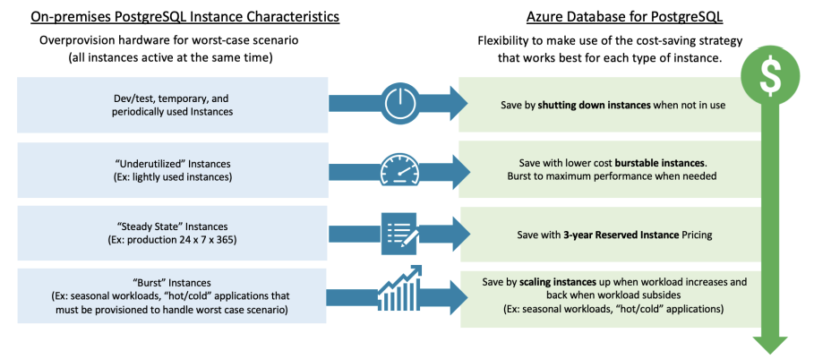

Figure 1

Figure 1 elucidates the comparison between regular PostgreSQL characteristics and Azure Database for Postgre SQL.

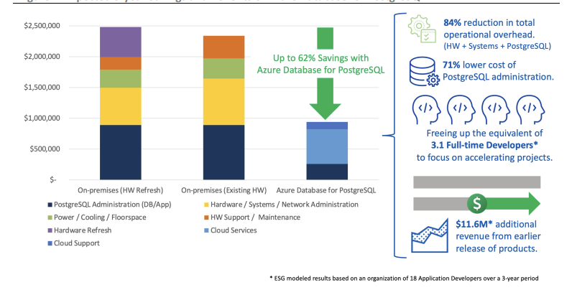

Figure 2

Figure 2 elucidates the amount of savings if the organization migrates to Azure Database.

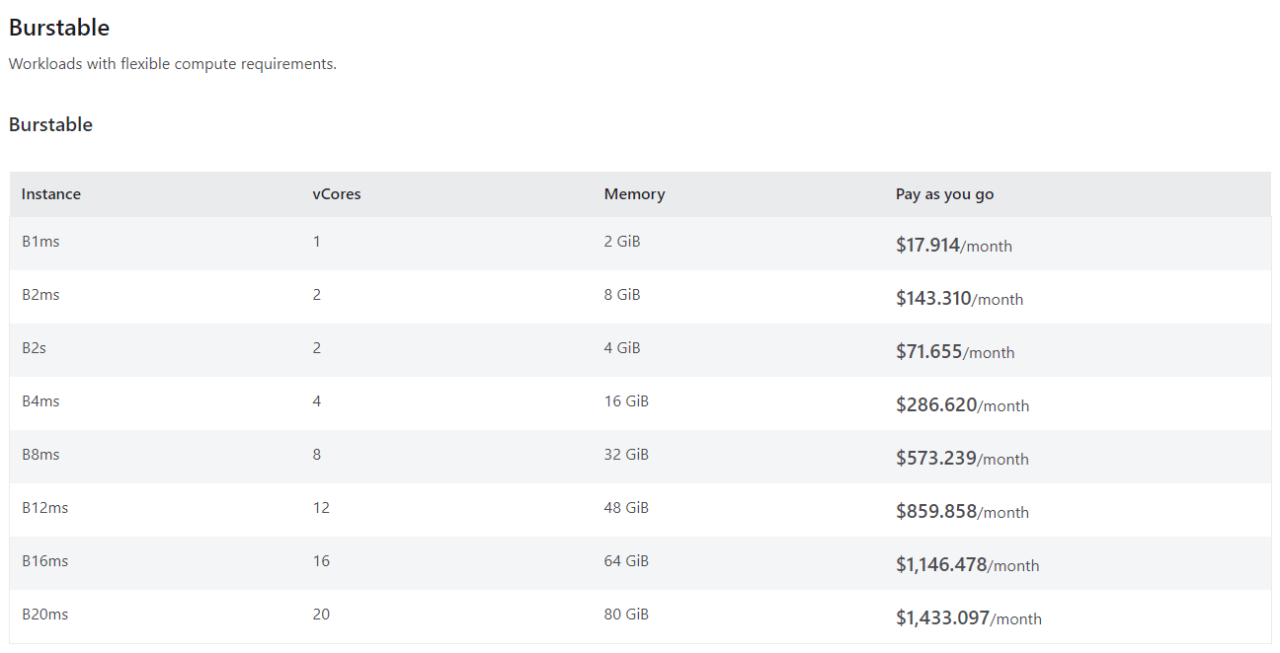

Figure 3

Figure 3 shows the cost for Burstable

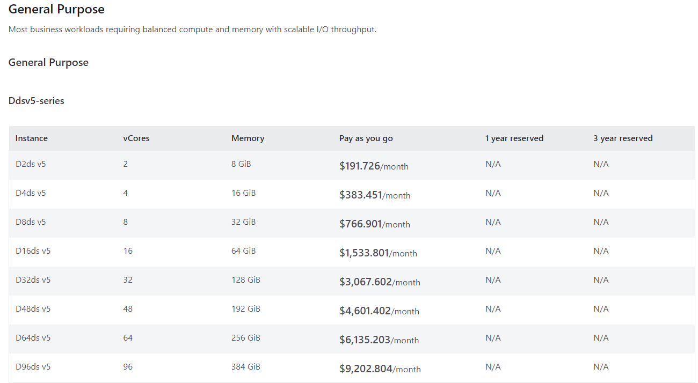

Figure 4

Figure 4 shows the cost for General Purpose

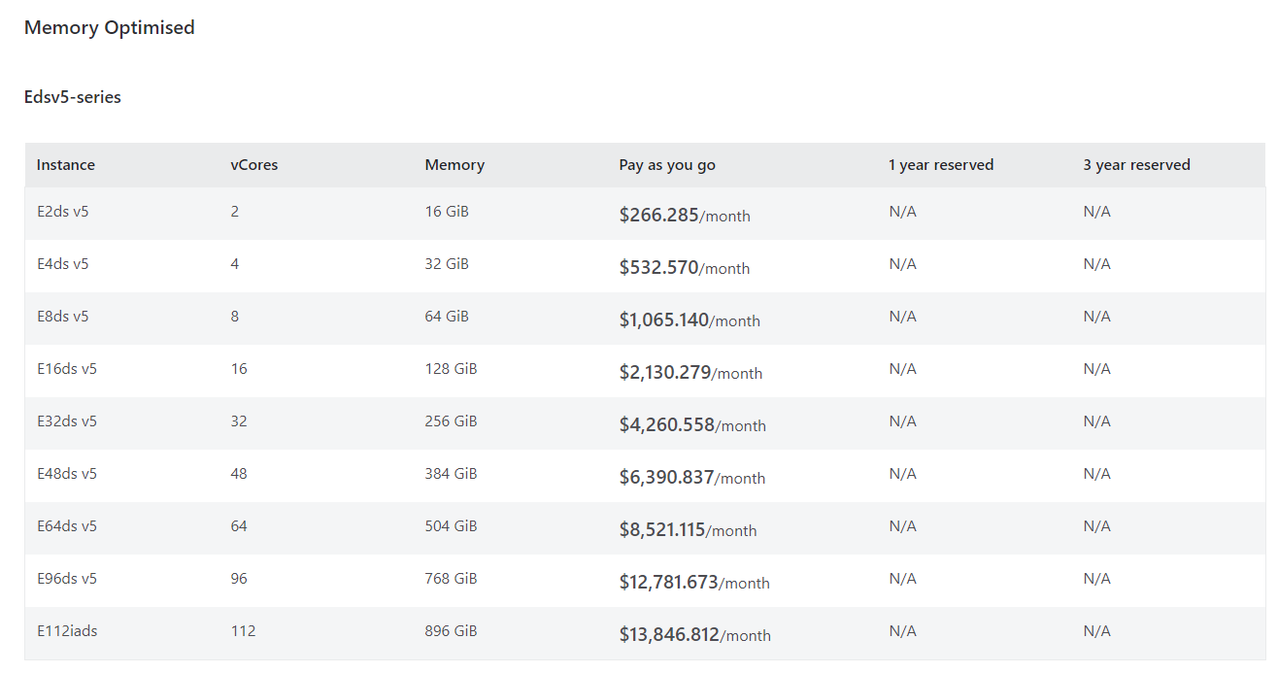

Figure 5

Figure 5 shows the cost for Memory Optimized

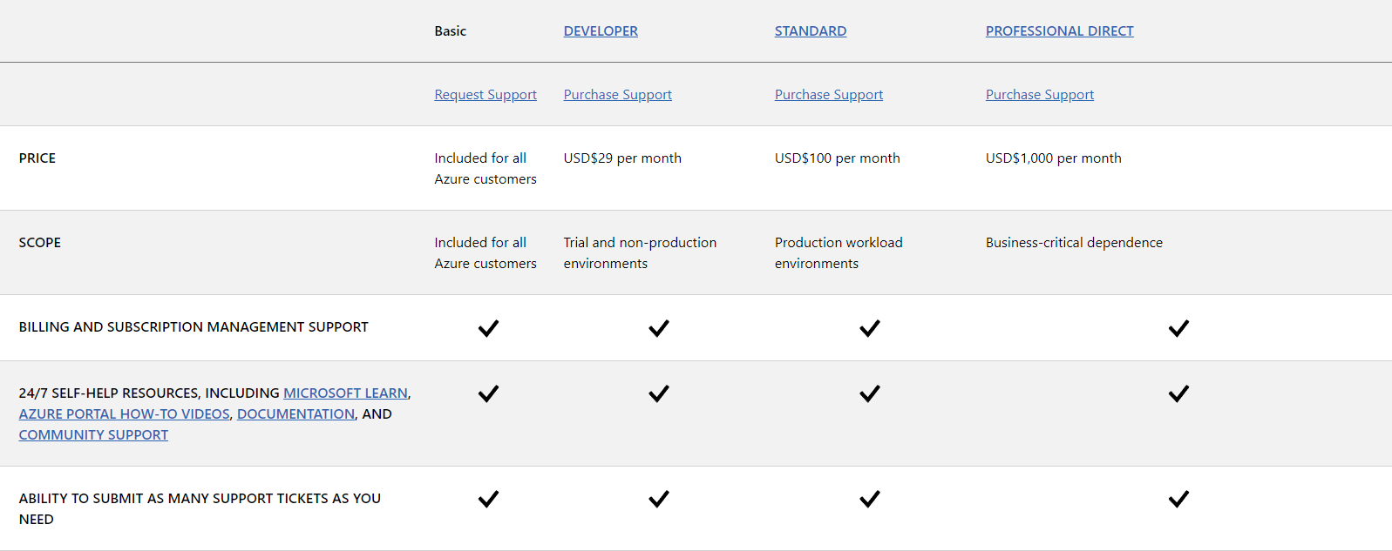

Figure 6

Figure 6 shows the cost, support services and other features for each Azure service.

**REFERENCES**

1. Microsoft. (n.d.). Azure Database for PostgreSQL. *Microsoft.* Retrieved from <https://azure.microsoft.com/en-us/services/postgresql/>

2. Microsoft. (2023, March 28). Secure your database - Azure Database for PostgreSQL - Single Server. *Microsoft.* Retrieved from <https://docs.microsoft.com/en-us/azure/postgresql/concepts-security>

3. Microsoft. (2023, March 28). Monitor Azure Database for PostgreSQL. *Microsoft.* Retrieved from <https://docs.microsoft.com/en-us/azure/postgresql/concepts-monitoring>

4. Microsoft (2022, September 13). Scale up and down as Azure Database for PostgreSQL server using CLI (az or kubectl). *Microsoft.* Retrieved from: <https://learn.microsoft.com/en-us/azure/azure-arc/data/scale-up-down-postgresql-server-using-cli>

5. Microsoft (2023, March 28). High availability in Azure Database for PostgreSQL – Single Server. *Microsoft.* Retrieved from <https://learn.microsoft.com/en-us/azure/postgresql/single-server/concepts-high-availability>

6. Kaufmann, A., Duey, J. ( 2022, July). Analyzing the Economic Benefit of Migrating from On-Premises Instances to Azure Database for PostgreSQL. *Enterprise Strategy Group.* Retrieved from <https://azure.microsoft.com/mediahandler/files/resourcefiles/analyzing-the-economic-benefit-of-migrating-from-on-premises-instances-to-azure-database-for-postgresql/ESG-Economic-Validation-Microsoft-Azure-Database-for-PostgreSQL-Jul-2022.pdf>

7. Microsoft. (2021. October 29). Scandinavian Airlines speeds app development, lowers costs with Azure Database for PostgreSQL. *Microsoft.* Retrieved from [ttps://customers.microsoft.com/en-us/story/1431763554334987166-scandinavian-airlines-speeds-app-development-lowers-costs-azure-database-postgresql](https://customers.microsoft.com/en-us/story/1431763554334987166-scandinavian-airlines-speeds-app-development-lowers-costs-azure-database-postgresql)

8. Microsoft. (2023, March 08). Kantar Group’s Media business accelerates insights, goes cloud-native with Azure Cosmos DB for PostgreSQL. *Microsoft.* Retrieved from <https://customers.microsoft.com/en-us/story/1612552305790806253-kantar-media-business-accelerates-insights-with-azure-cosmos-db-for-postgresql>

9. InfluxData. (n.d.). Microsoft Azure. *InfluxData* .Retrieved from: <https://www.influxdata.com/partners/microsoft-azure/>

10. Verma, R. (2022, February 18). Connecting DBeaver PostgreSQL via JDBC Driver: 4 East Steps. *Hevo*. Retrieved from: <https://hevodata.com/learn/dbeaver-postgresql/>

11. Corneli, M. (2021, March 30). Unlock the value of your Azure data with Tableau. *Tableau*. Retrieved from: <https://www.tableau.com/blog/unlock-the-value-azure-data-with-tableau>

12. Dadakh, N. (2023, January, 19). Why Django is so impressive for developing with PostgreSQL and Python. *EDB*. Retrieved from: <https://www.enterprisedb.com/postgres-tutorials/why-django-so-impressive-developing-postgresql-and-python>

13. Microsoft (2023)*. Tutorial: Migrate PostgreSQL to Azure Database for PostgreSQL online using DMS (classic) via the Azure portal. Retrieved from* [*https://learn.microsoft.com/en-us/azure/dms/tutorial-postgresql-azure-postgresql-online-portal*](https://learn.microsoft.com/en-us/azure/dms/tutorial-postgresql-azure-postgresql-online-portal)

14.Microsoft (n.d.). *Azure Database for PostgreSQL pricing.* Retrieved from <https://azure.microsoft.com/en-ca/pricing/details/postgresql/server/>

*15.Microsoft (2023). Planned maintenance notification in Azure Database for PostgreSQL - Single Server.* Retrieved from[*https://learn.microsoft.com/en-us/azure/postgresql/single-server/concepts-planned-maintenance-notification*](https://learn.microsoft.com/en-us/azure/postgresql/single-server/concepts-planned-maintenance-notification)

16. ManageEngine (n.d.). PostgreSQL Performance Monitoring. *ManageEngine.* Retrieved from <https://www.manageengine.com/products/applications_manager/postgresql-performance-monitoring.html?network=o&device=c&keyword=postgresql%20monitoring&campaignid=401373849&creative=&matchtype=e&adposition=&placement=&adgroup=1307319578884219&targetid=kwd-81707623038044:loc-32&searchterm=monitoring%20and%20performance%20management%20in%20postgreSQL&msclkid=1f71571c0eeb11f6a73f33d40eb8c1ae&utm_source=bing&utm_medium=cpc&utm_campaign=APM%20-%20CAN%20-%20%20INR%20-%20Search%20-%20Core%20-%20Exact%20-%20L1%20-%20Bing&utm_term=postgresql%20monitoring&utm_content=APM%20-%20PostgreSQL%20Monitoring%20-%20L1>

17. Matherson, N. (2023, July 11). Postgres Performance Monitoring: Best Practices and Tools to Use. *Hydra.* Retrieved from <https://www.hydra.so/blog-posts/2022-08-08-postgres-performance-monitoring-best-practices-and-tools>

18. Learn-Azure (2023, May 05). Security and Compliance Certification in Azure Database for PostgreSQL – Flexible Server. *Microsoft*. Retrieved from <https://learn.microsoft.com/en-us/azure/postgresql/flexible-server/concepts-compliance> (Learn-Azure, 2023)

19. Learn-Azure (n.d.). Azure Database for PostgreSQL documentation. *Microsoft.* Retrieved from: <https://learn.microsoft.com/en-us/azure/postgresql/>

2O. Learn-Training (n.d.). Introduction to Azure Database for PostgreSQL. *Microsoft.* Retrieved from <https://learn.microsoft.com/en-us/training/modules/intro-to-postgres/>

21. Azure (n.d.). Compare Support Plans. *Microsoft.* Retrieved from <https://azure.microsoft.com/en-us/support/plans>

22. Jason Meilleur (2019, July). 4 Reasons Microsoft Azure Cloud is the Right Move for your Business. *360 Visibility*. Retrieved from: <https://www.360visibility.com/4-reasons-microsoft-azure-cloud-is-the-right-move-for-your-business/>

23. Microsoft (2023). High availability concepts in Azure Database for MySQL - Flexible Server. *Microsoft*. Retrieved from: <https://learn.microsoft.com/en-us/azure/mysql/flexible-server/concepts-high-availability>

24. Varun Dhawan (2022). How to check logs for Azure Database for PostgreSQL. Retrieved from: <https://techcommunity.microsoft.com/t5/azure-database-for-postgresql/how-to-check-logs-for-azure-database-for-postgresql/ba-p/3618983>

25. Mullins, Craig (2002). Database administration: the complete guide to practices and procedures. Retrieved from: <https://archive.org/details/databaseadminist0000mull>

26. JSONB. Retrieved from: <https://www.cockroachlabs.com/docs/stable/jsonb#:~:text=The%20JSONB%20data%20type%20stores,API%2C%20see%20the%20JSON%20tutorial>.

27. Microsoft (2023). Azure Database for PostgreSQL. *Microsoft*. Retrieved from: <https://azure.microsoft.com/en-ca/products/postgresql/?ef_id=_k_Cj0KCQjwn_OlBhDhARIsAG2y6zMHJXAeIl_-NOyW78ix0aZV9xW5FBZZ0tep6oFcxAcqnGUy4IsOnq4aAlpkEALw_wcB_k_&OCID=AIDcmmqz3gd78m_SEM__k_Cj0KCQjwn_OlBhDhARIsAG2y6zMHJXAeIl_-NOyW78ix0aZV9xW5FBZZ0tep6oFcxAcqnGUy4IsOnq4aAlpkEALw_wcB_k_&gad=1&gclid=Cj0KCQjwn_OlBhDhARIsAG2y6zMHJXAeIl_-NOyW78ix0aZV9xW5FBZZ0tep6oFcxAcqnGUy4IsOnq4aAlpkEALw_wcB>

28. Microsoft (2022). Azure Active Directory Authentication with PostgreSQL Flexible Server. *Microsoft.* Retrieved from: <https://learn.microsoft.com/en-us/azure/postgresql/flexible-server/concepts-azure-ad-authentication>

29. Team CBT Nuggets (2022). Retrieved from: <https://www.cbtnuggets.com/how-long-to-study>

30. User based reviews on Azure retrieved from: <https://www.trustradius.com/reviews/microsoft-azure-2022-11-25-03-21-14>